DAY 10

CLASS EXERCISE 1

    @PostMapping("/api/door")

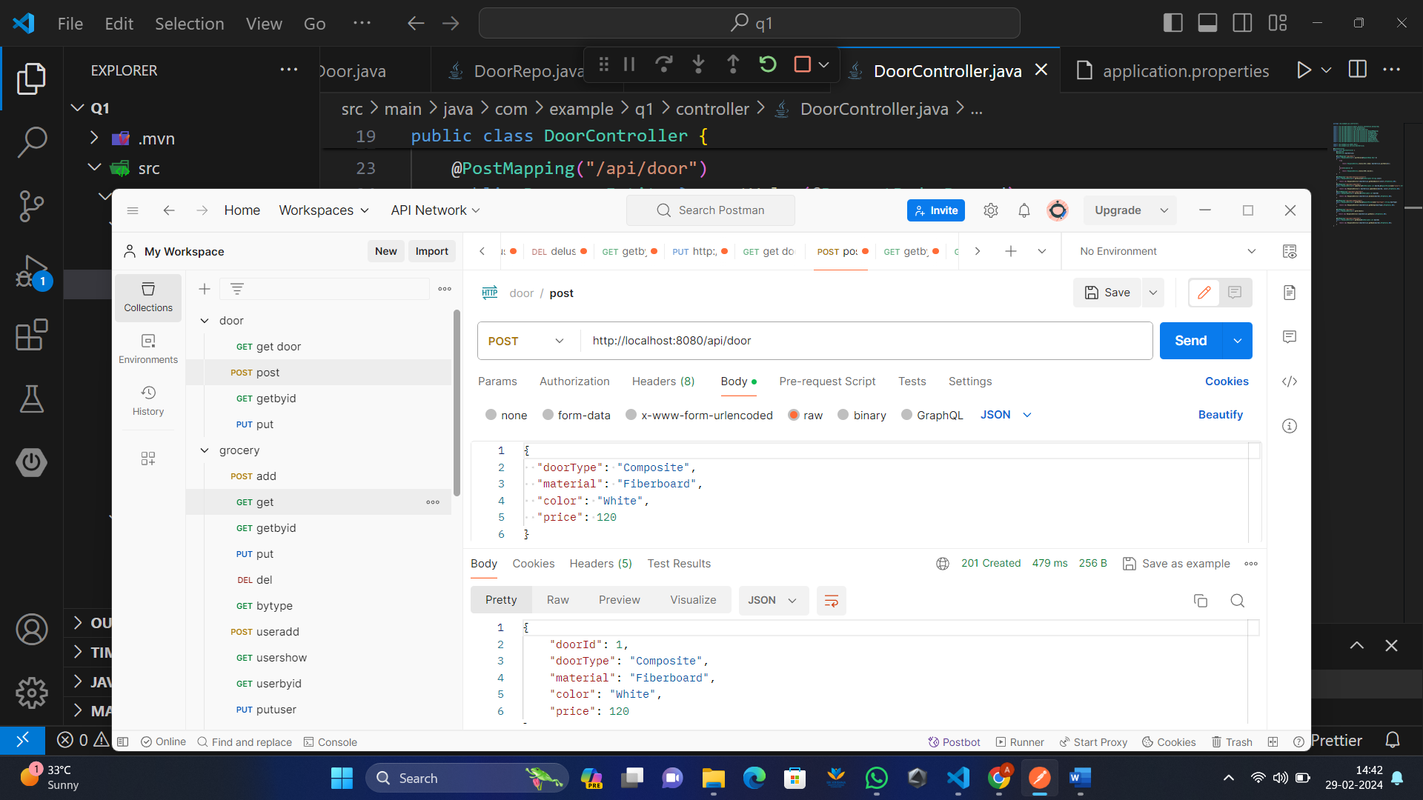

  @GetMapping("/api/door")

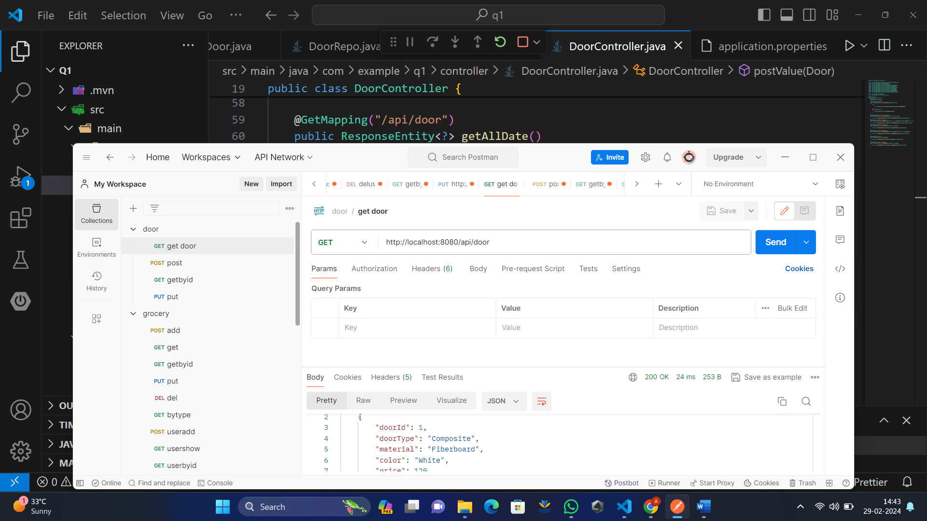

    @GetMapping("/api/door/{doorId}")

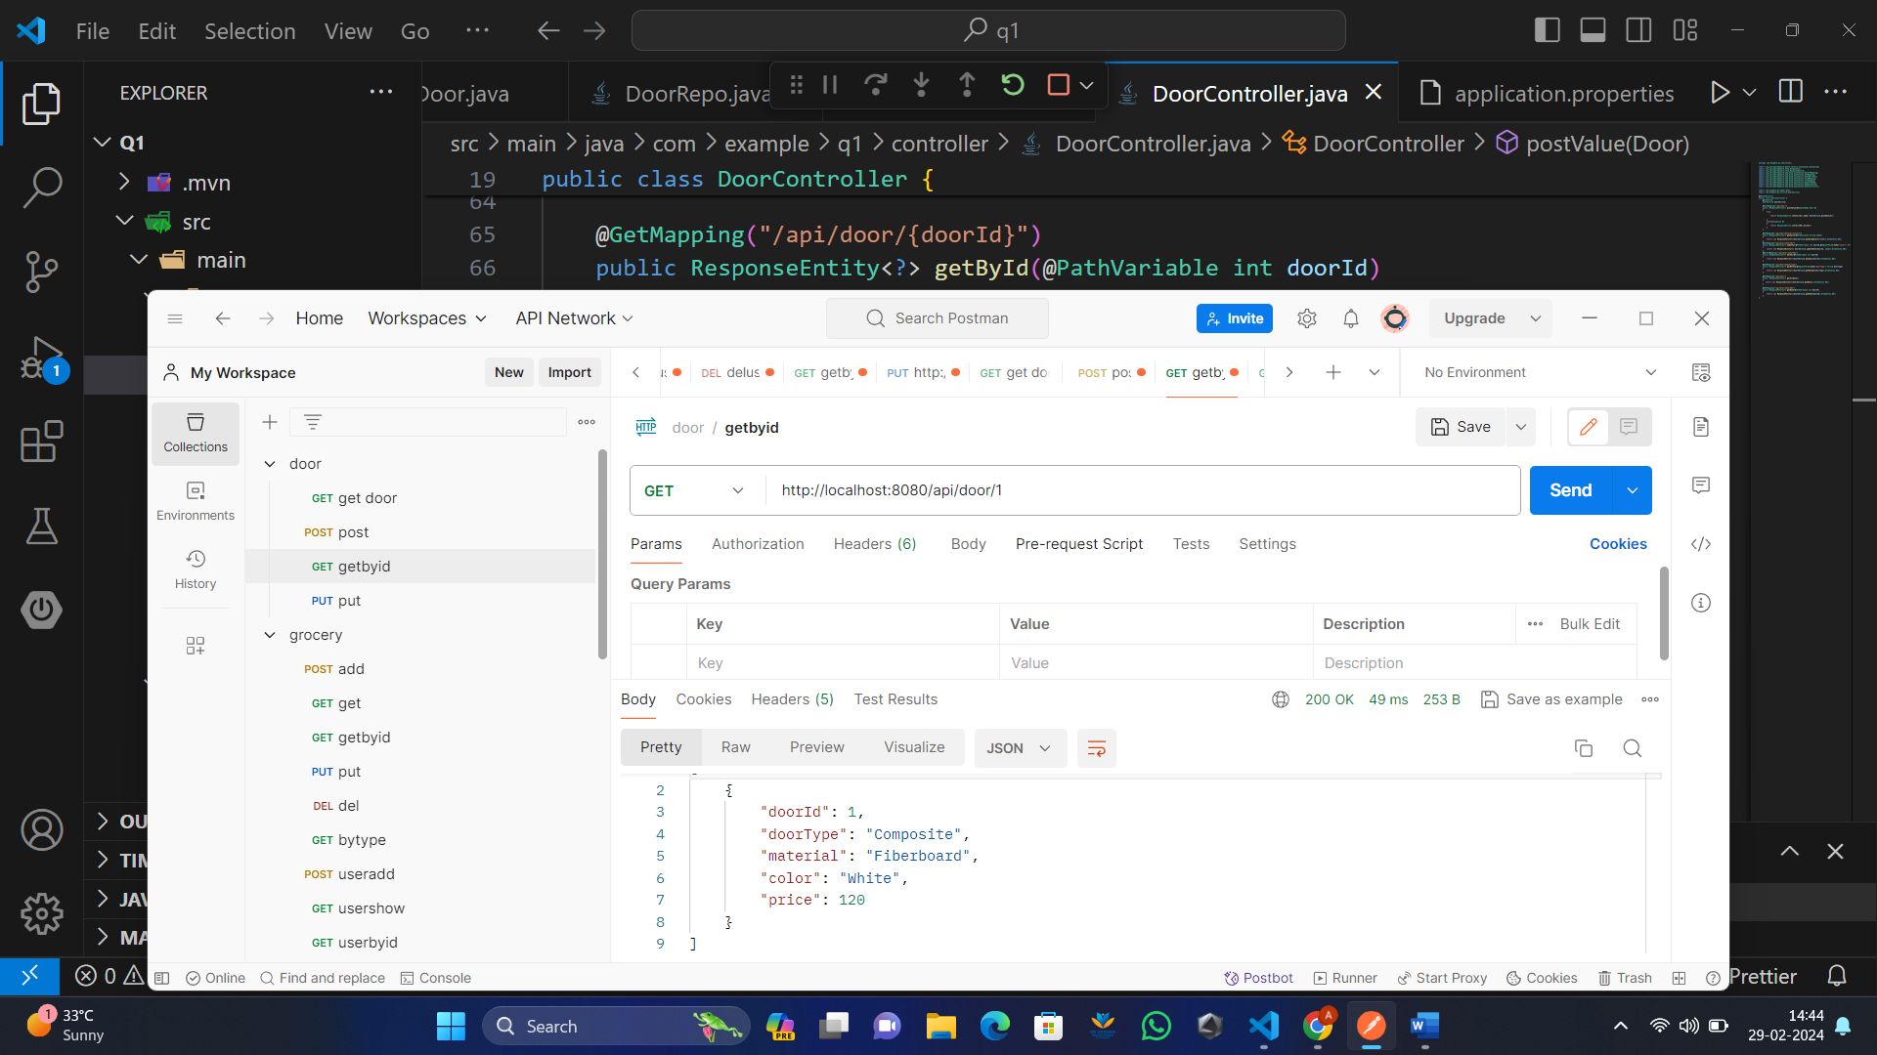

    @PutMapping("/api/door/{doorId}")

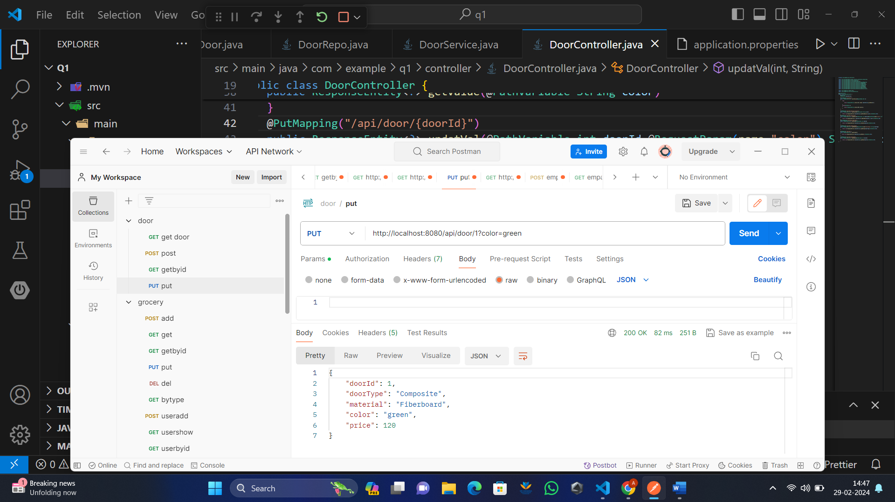

    @GetMapping("/api/door/bydoortype")

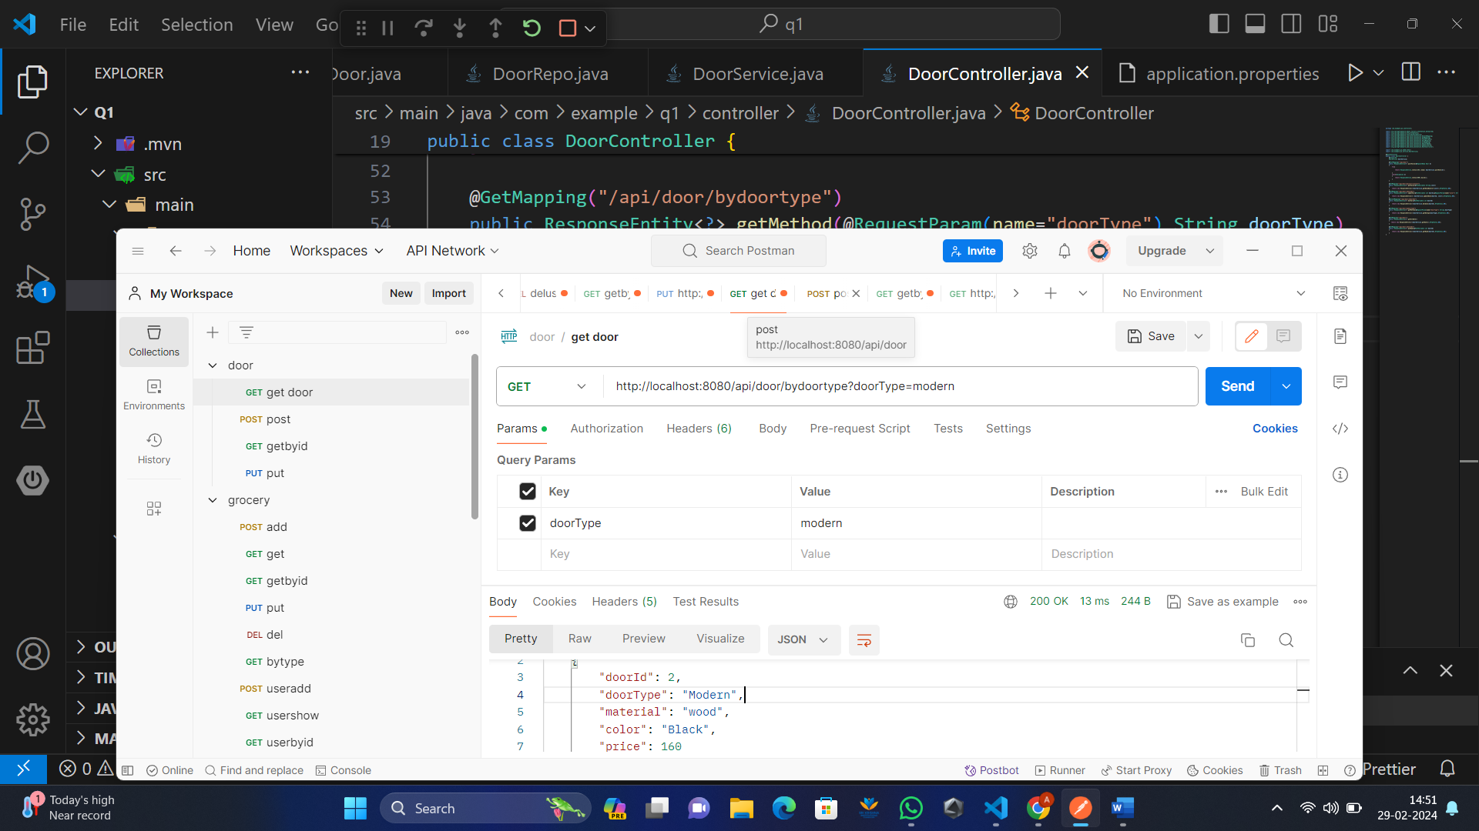

    @GetMapping("/api/door/bycolor/{color}")

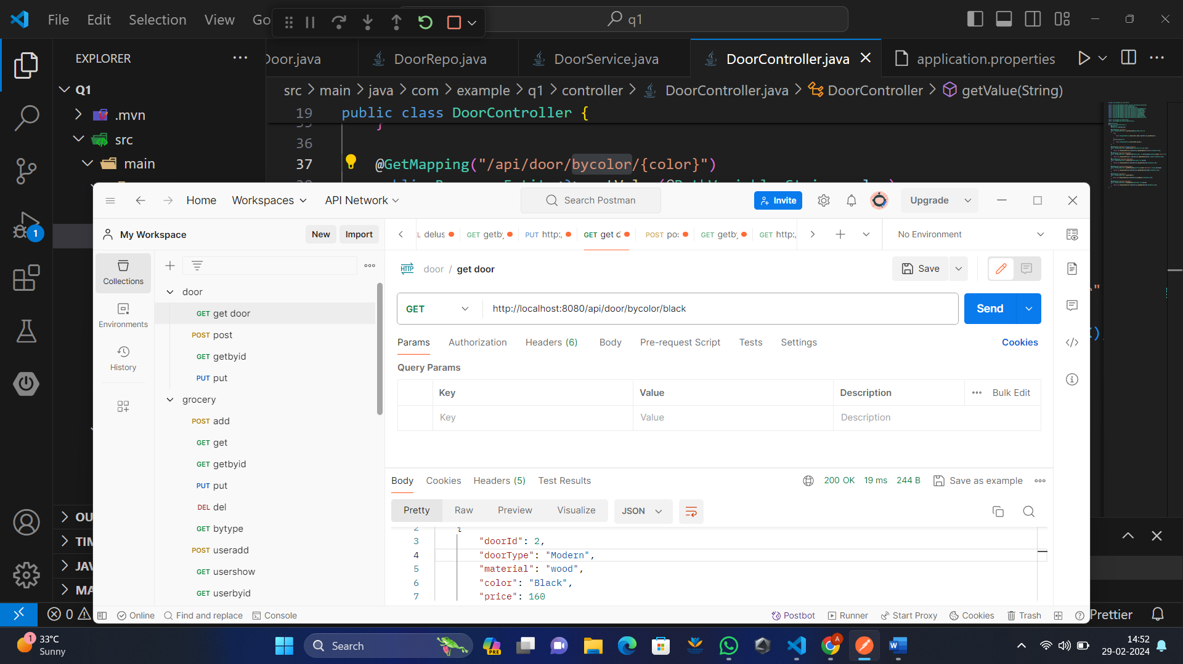

    @DeleteMapping("/api/door/{doorId}")

